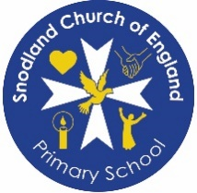
Curriculum Overview EYFS 2025-2026
 | Term 1 | Term 2 | Term 3 | Term 4 | Term 5 | Term 6
Phonics | 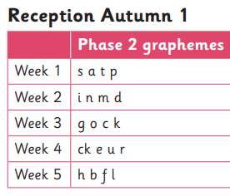  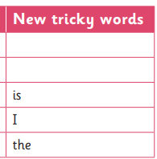 | 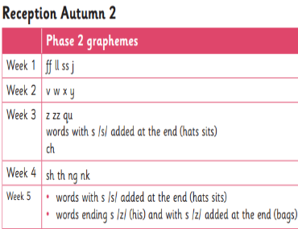  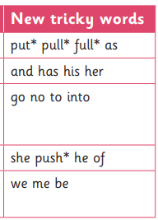 | 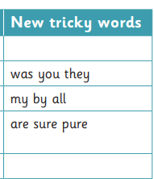  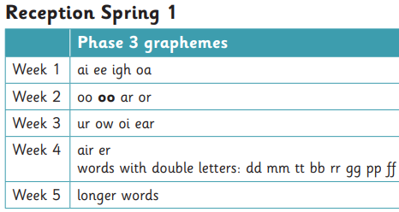 | 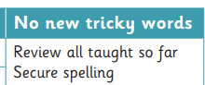  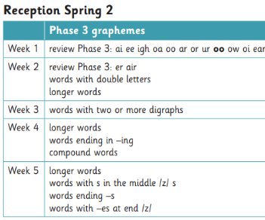 | 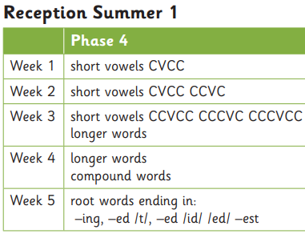  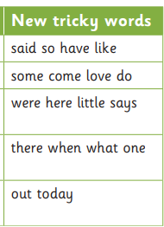 | 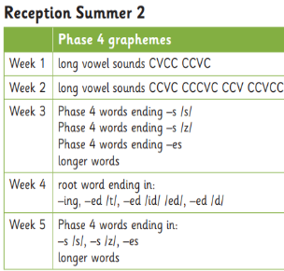  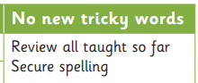
Literacy- Key texts | Magical Story Time and Talk through Stories (covering a range of lovely texts) | 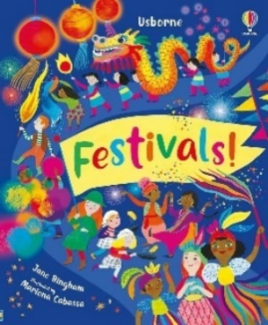  Festivals by Jane Bingham | 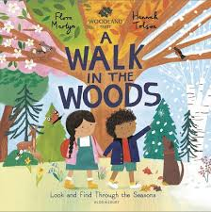  A Walk in the Woods by Flora Martyn | 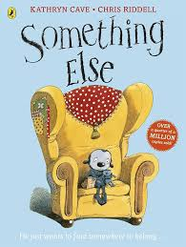  Something Else by Kathyrn Caves | 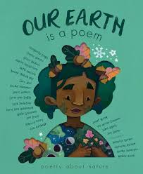  Our Earth is a Poem by Margarita Engle | 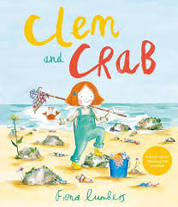  Clem and Crab by Fiona Lumbers
Maths | -Early mathematical experiences.  -Pattern and early number.  -Numbers within 6.  -Addition and subtraction within 6.  -Measures.  -Shape and sorting. |  | -Number within 10.  -Calendar and time.  -Addition and subtraction within 10  -Grouping and sharing.  -Number patterns withing 15.  -Doubling and halving.  -Shape and pattern. |  | -Securing addition and subtraction.  -Number patterns within 20.  -Number patterns beyond 20.  -Money.  -Measures.  -Exploration of patterns within number.
Understanding the World | All about me.  -My family.  -Look how I have  grown.  -People who help us.  -What do I want to be  when I gown up?  -Seasons | Let’s celebrate  -Exploring events and  celebrations from around  the world. | Come outside  -Plants and flowers.  -Seasons and weather. | Amazing animals  -Life cycles.  -Animals from around the  world.  -Hibernation.  -Down on the farm.  -Mini beasts. | Ticket to Ride  -Where do we live in  the UK/world.  -Around the town.  -How do get there?  -Where in the world  have you been? | Fun at the Seaside  -Under the sea.  -Off on holiday!  -Where shall we go?  -What clothes will we  need?  -The seaside in the past.  -Material.  -Reduce, Reuse and recycle.  -Seasons.  -Climates
PSED | Being me in my world | Celebrating differences | Dreams and goals | Healthy me | Relationships | Changing me
RE | God and Creation  Why is the word ‘God’ so important to Christians? | Old Testament Stories Which stories are special and why? Incarnation Why do Christmas perform nativity plays at Christmas? | New Testament Stories Which stories are special and why? | Salvation  Why do Christians put a cross in an Easter Garden? | World Faith Stories Which stories are special and why? | Word Faith Stories  Which stories are special and why?
Expressive Art and Design | -Movement maps  -Leaf rubbing.  -Design a Harvest  Festival box.  -Junk modelling. | -Explore Claude Monet.  -Make Diya lamps.  -Explore Wassily Kandinsky.  -Explore healthy foods/make  fruit kebabs.  -Christmas arts and crafts. | -Seasonal arts.  -Design and make  detective badges.  -Make x-ray images.  -Make Chinese lanterns.  -Design and make a house.  -Celebration art  enhancements. | -Exploring colour.  -Exploring instruments. | -Creating an under  the sea diorama. | -Design and paint  patterns on T-shirts.
PE | BEAM | Gymnastics  (Gym in the jungle) | Dance  (Dinosaurs) | Ball Skills  (Best of Balls) | Dance  (Dance till you drop) | Games  (The Olympics)

